DAT 530 uCertify Lab Activity Worksheet

Module Labs
- 1.3.1 Creating a Bar Plot and Calculating the Mean Growth Rate Distribution
- 1.3.3 Plotting a Histogram
- 1.4.1 Tweaking the Plot Parameters of a Grouped Bar Plot
- 1.4.2 Annotating a Bar Chart

Lab Screenshots
- 1.3.1 Creating a Bar Plot and Calculating the Mean Growth Rate Distribution
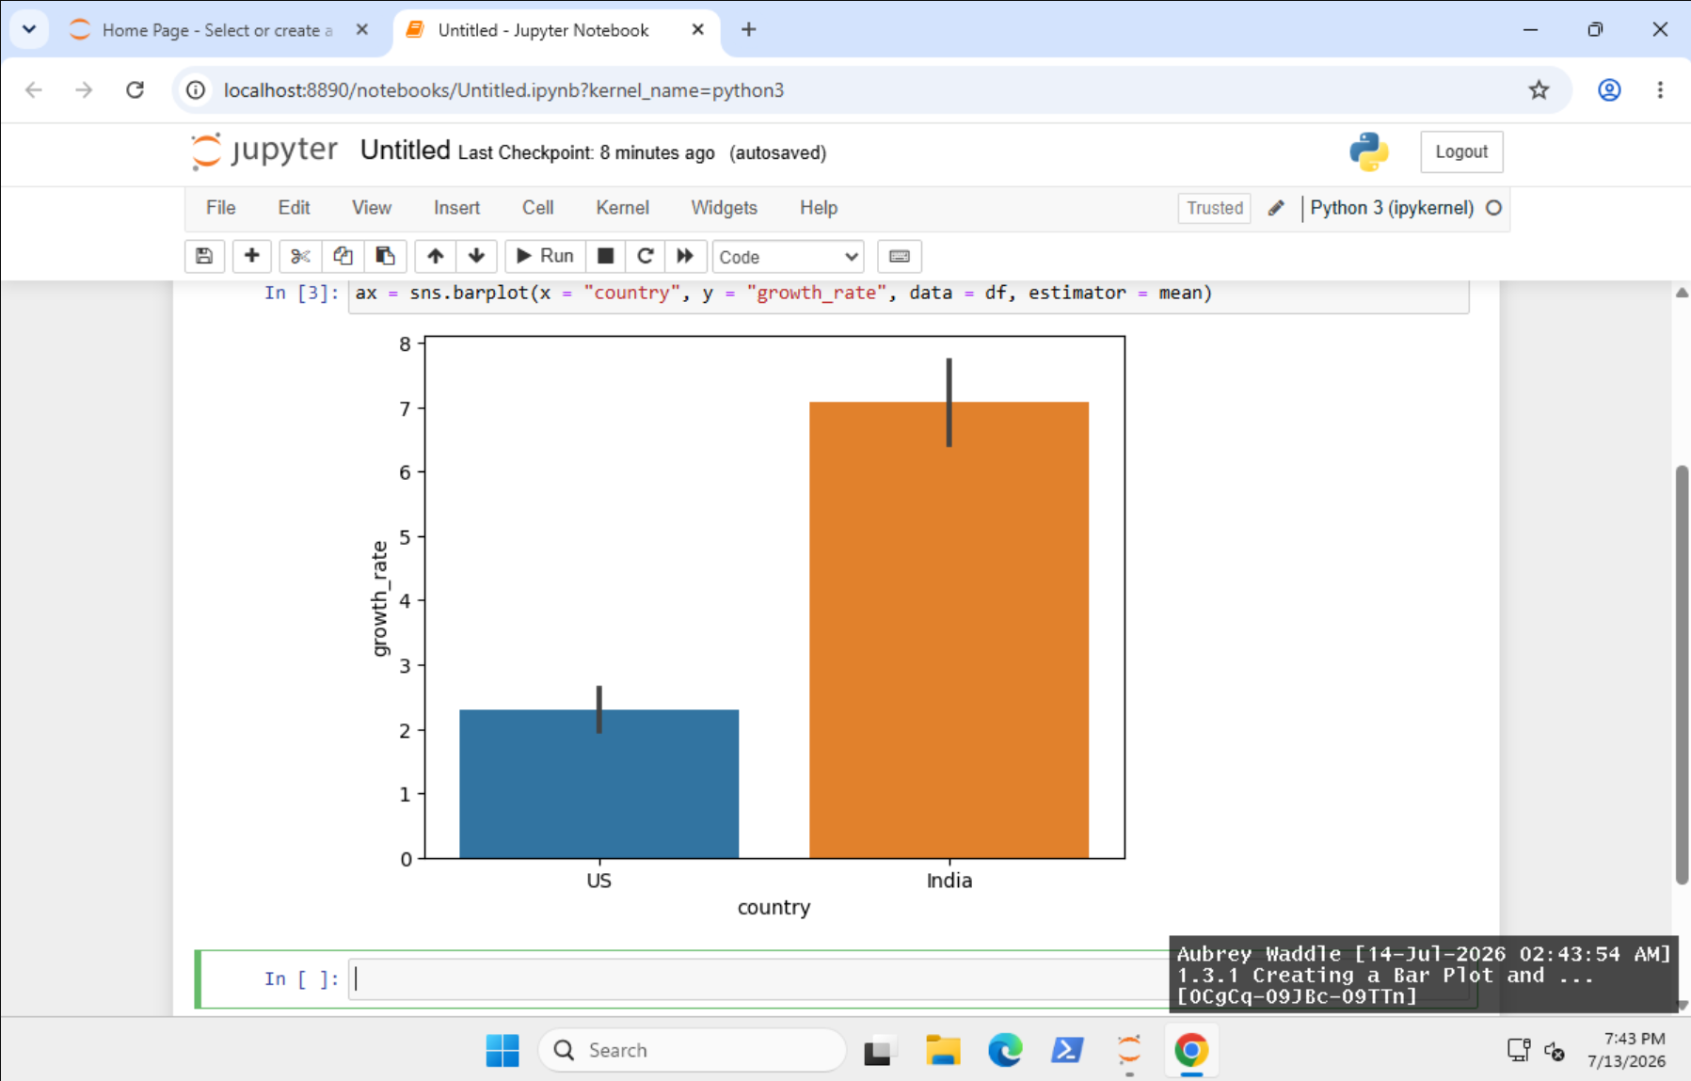
- 1.3.3 Plotting a Histogram
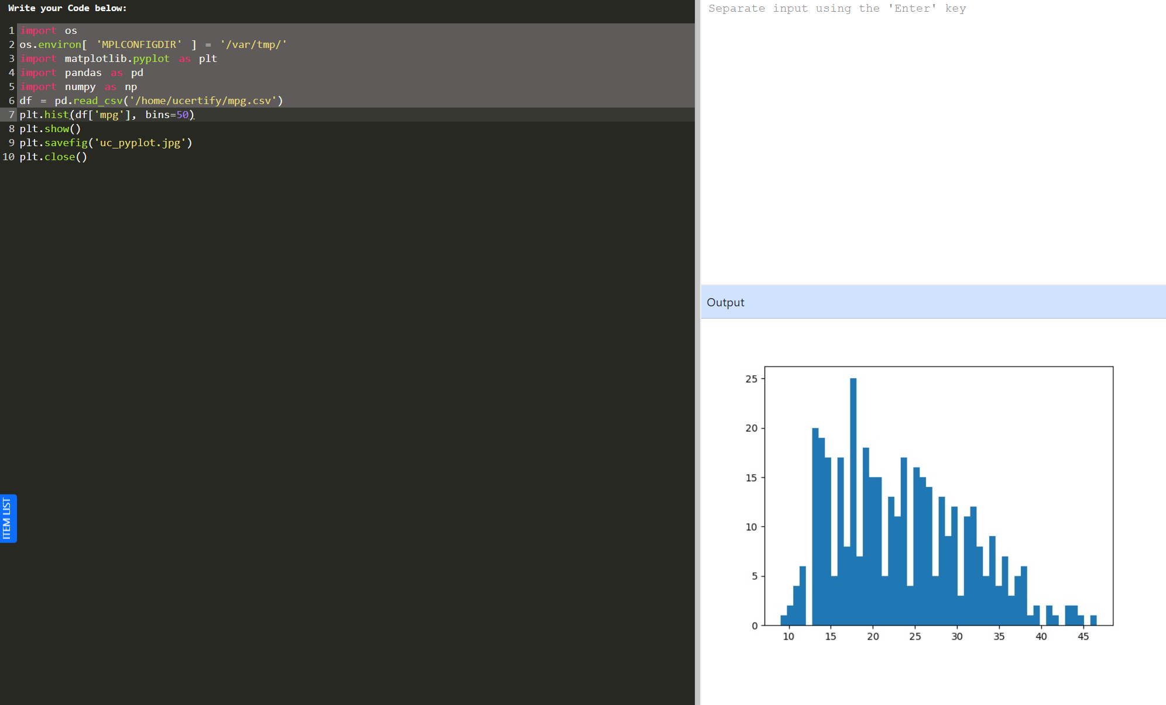
- 1.4.1 Tweaking the Plot Parameters of a Grouped Bar Plot
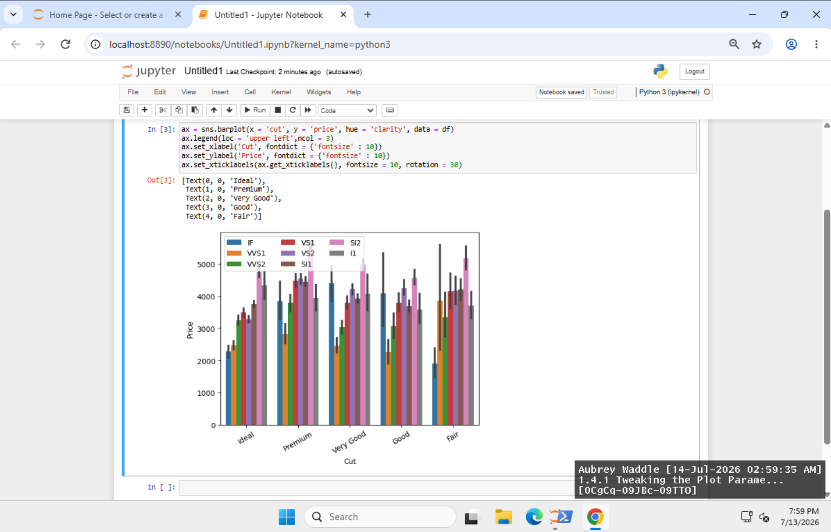
- 1.4.2 Annotating a Bar Chart
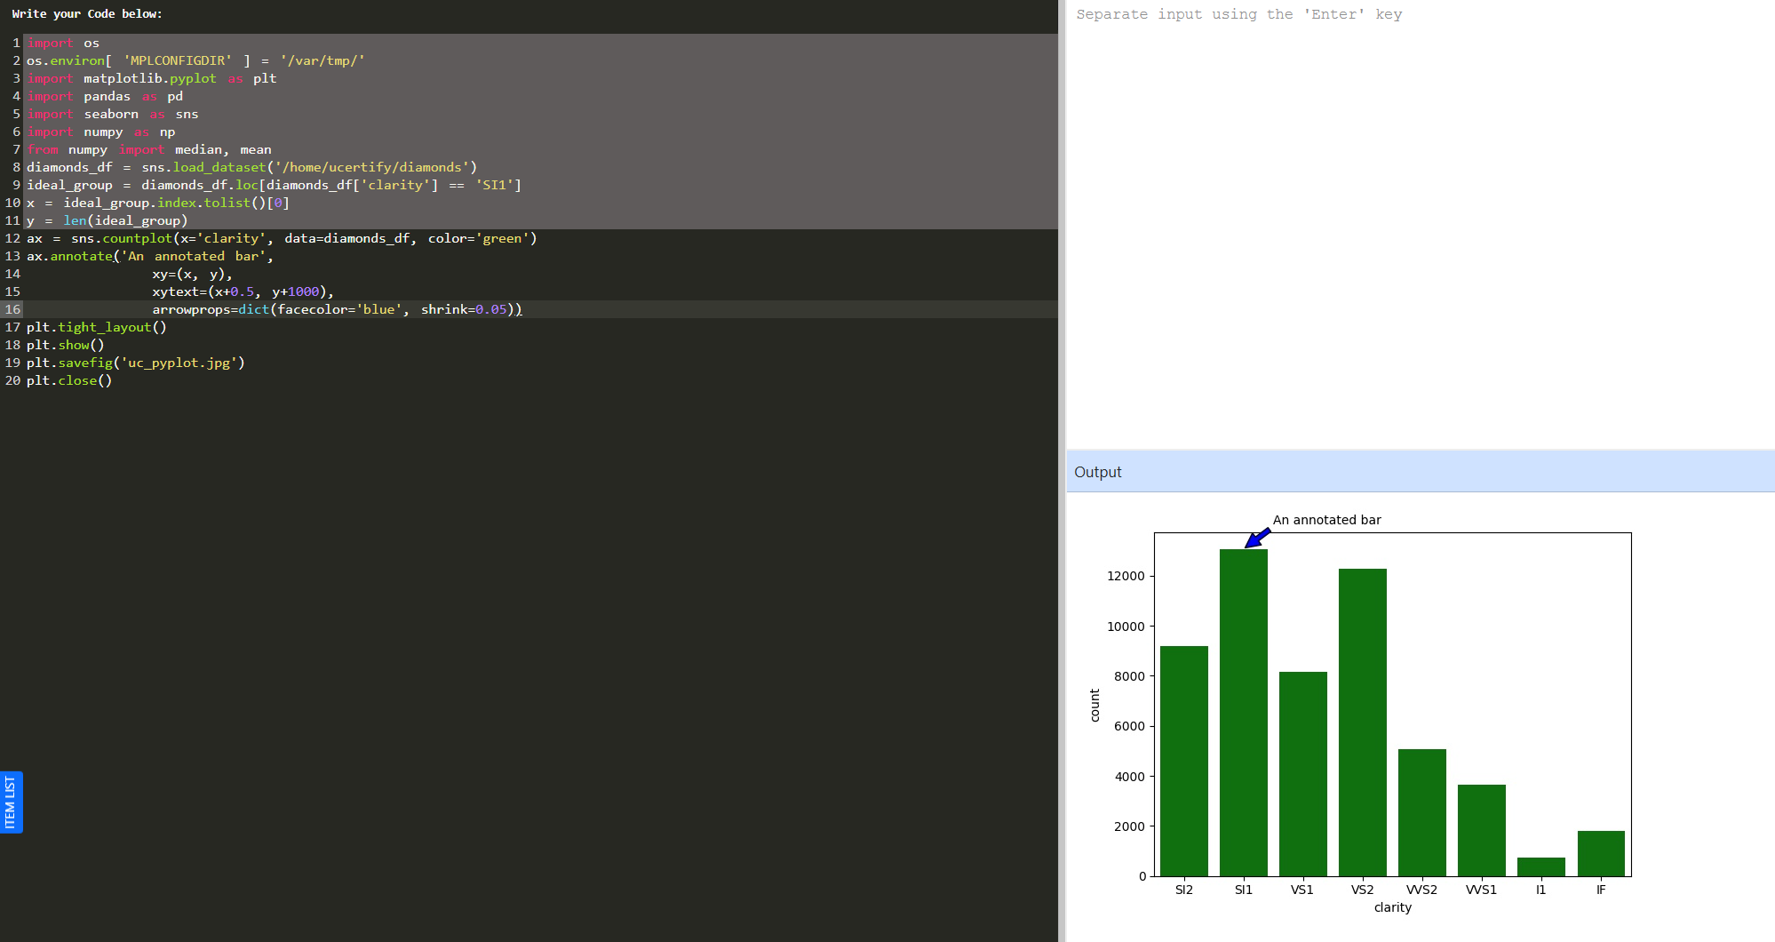

Lab Reflection
In one to two paragraphs, reflect on the uCertify labs you completed by responding to the following prompt:

- Briefly reflect on your work in this week’s data visualization labs. Discuss the tools and techniques you used and the visualizations or processes you created, noting any key similarities or differences. What types of audiences are these visualizations most suitable for?

- 1.3.1 Creating a Bar Plot and Calculating the Mean Growth Rate Distribution
For this lab I used Seaborn to make a bar graph comparing average growth rates of many countries. It then automatically determined the mean growth rate per country and plotted the data . The line of code Ax = sns.barplot(x="country", y="growth_rate", data=df, estimator=mean) was key to this calculation . Business stakeholders are able to get a quick sense of team performance and compare averages across multiple areas.

- 1.3.3 Plotting a Histogram
The objective of this lab was to create a histogram to show how a set of data is distributed. You may draw histogram by using the built-in charting feature of pandas. What you want is this : df.hist(column='mpg', bins=50) I first approached the problem using plt.hist() from Matplotlib, but the visualizations are the same with both methods since pandas uses Matplotlib implicitly. Histograms are useful for analysts as they make it easier to determine the distribution, shape and outliers in a data set. This is important to do before doing any further analysis.

- 1.4.1 Tweaking the Plot Parameters of a Grouped Bar Plot
For this lab I made a clustered bar chart and changed the layout quite a bit so it was more readable. sns. barplot ( x = 'cut', y = 'price', color = 'clarity', data = df ) Output: The graphic contrasted pricing of diamonds across cut categories, with the bars colored according to clarity. Then the legend, axes labels and tick labels were changed. For example, even little stylistic tweaks can significantly improve the intelligibility of a visualization for audiences that need to make quick comparisons across many categories, such as business users.

- 1.4.2 Annotating a Bar Chart
In this lab we first introduced annotations for charts, pointing an arrow and text to the attention of one single bar. The primary code used was sns.plt.annotate('An annotated bar', xy=(x,y), xytext=(x+0.5, y+800), arrowprops=dict(facecolor='blue')) after catplot(x='clarity', data=diamonds_df, aspect=1.5, kind='count', color='g'). The lab wants me to use catplot() instead of sns.countplot() with ax.annotate() but I have fixed the problem with that way. This example demonstrates that there are often multiple ways to create the same visualization in Python, however both solutions do provide an annotated count chart. It can be difficult to communicate results to a non-technical audience, but annotating charts can be a useful method to make the key information immediately stand out.

